Anatomy of a laser beam

**Overview**

The sound generated in this patch is three series of notes of oscillating amplitudes. The initial three amplitudes[fig. 1] are moderated by the red vSliders, the frequency is set by the yellow central vSlider, and the final three amplitudes are modified using the orange vSliders. The phasors[fig. 2] receive the input signals and generate sawtooth signal with a frequency determined by the previous binop elements. The phasors output three unique frequency signals whos amplitude is set by the yellow vSlider aswel. This signal is additively synthesised into the cosine oscillator, then passed through a levelling amplitude and finally emitted.

The message and line~ elements attached to the yellow vSlider create a slight gradient in amplitude between $1(the value of the slider) and the current amplitude over the space of 10 milliseconds.

This patch relies heavily on amplitude modulation to produce the wah-wah effect that has become the synonymous laser sound effect, even though any noise being emitted from a real-life laser would likely be an indicator of a dangerous defect in its design.

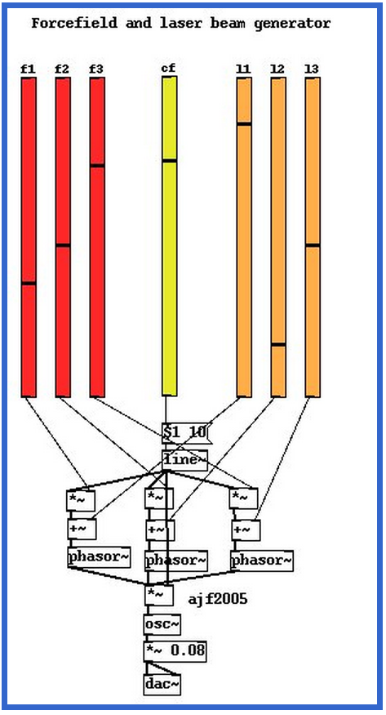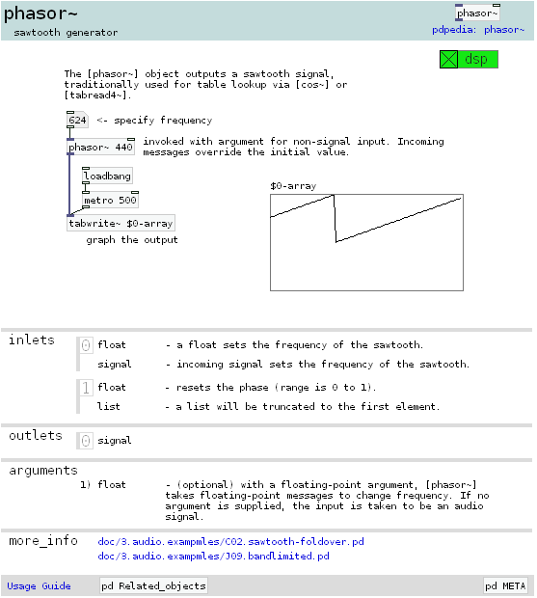

**[fig 1; patch demonstrating core laser functionality] [fig 2; help dialogue of phasor~]**

**Experimentation**

As shown above in figure 2, the phasor wave creates a saw toothed waveform, shown below [fig. 3] is a graph comparison of a sum of sawtooths versus a sum of cosine waves. Modifying the frequencies (red vSlider, modification shown with grey box) of the osc~s causes sub-waves to appear, then eventually become the most visible waveform. Modifying the phasor~ frequencies (same) causes the frequencies to tighten. One point to note, modifying the inputs of a cosine wave will always produce uniform results, whereas modifying a phasors inputs produces a non-uniform output.

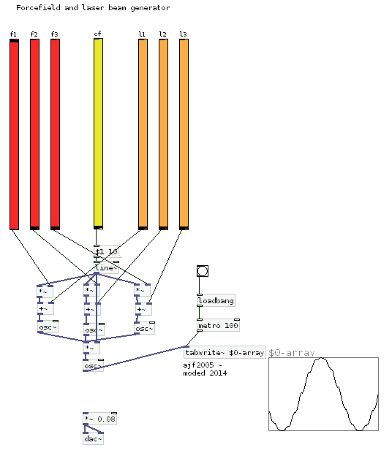 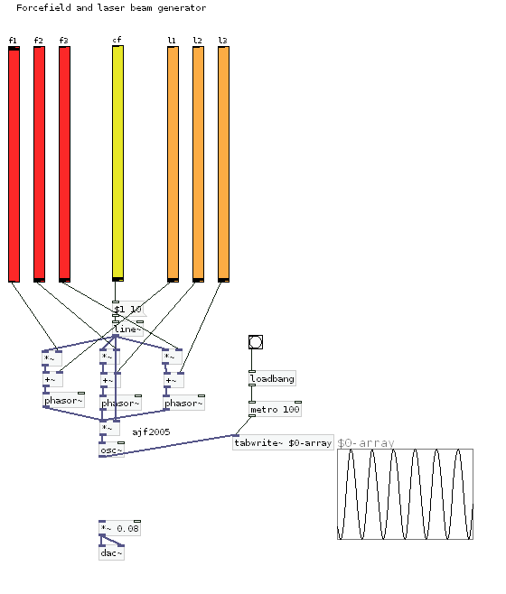

**[fig. 3a (left) cosine wave] [fig. 3a (right) phasor/ sawtooth wave]**

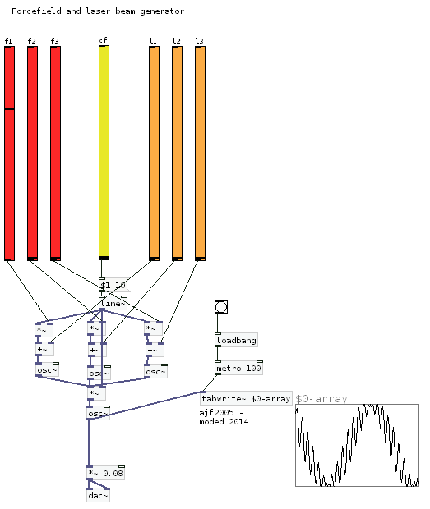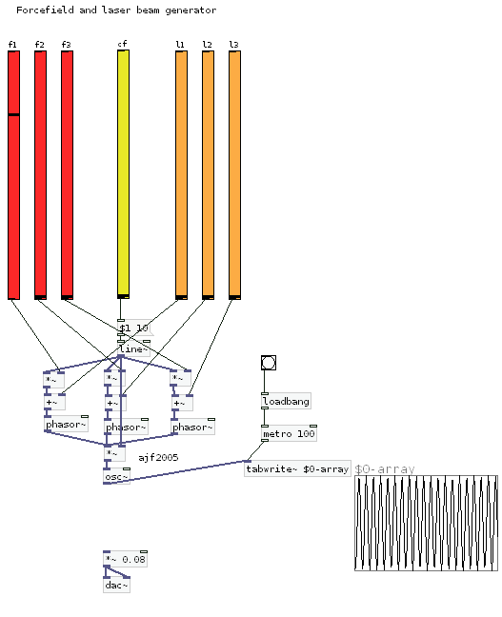

**[fig. 3b (left) cosine wave] [fig. 3b (right) phasor/ sawtooth wave]**

**Interactivity**

My patch modifications control how the various sliders adjust. Loading up the controller files gives you an interaction point, but should not be run at the same time, incase of audio clashes.

In example 1, I used a modified version of the original patch that can be found on the web page. The sliders changing results in a futuristic stereotypical 80’ computer noise. As the control frequency escalates and deescalates The sound produces bleeps and occasionally creates a little ticking noise, similar to a cylinder disk being read. I have created a controller patch to allow easy sestup and access to this kind of sound board.

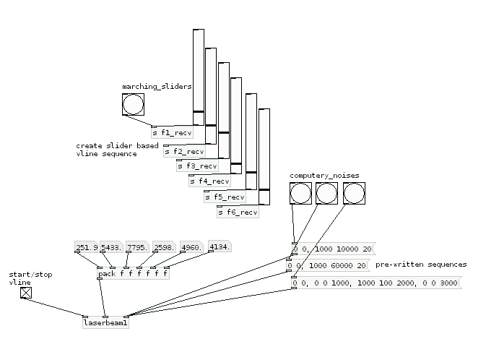Ingame, the noise could be used in a technical looking scene to illicit feelings of complex machinery whirring away processing some unknown algorithm or process. The sound engineer could use the vSliders in the controller to modify how long the sound plays, what range it plays within, and so forth.

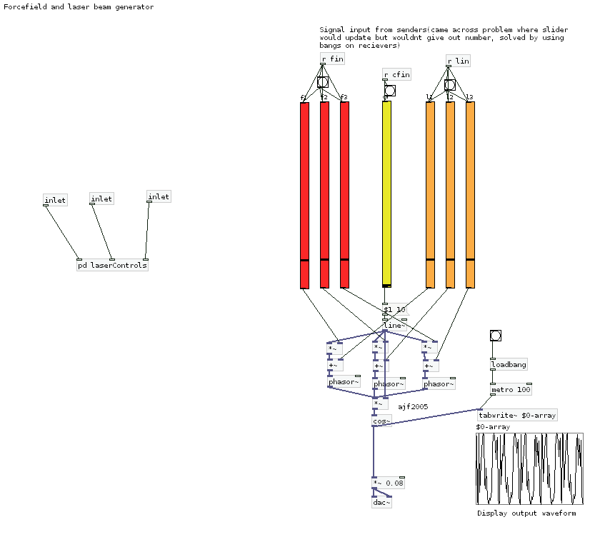

In Example 2, I removed a few elements, swapping out the phasors for oscillators and modifying the binary operators. This returned the sound of oscilloscope/ laser noises. This could be used in a similar “effect of research facility” styled purpose and could couple with the first patch to deepen the atmosphere of the map.

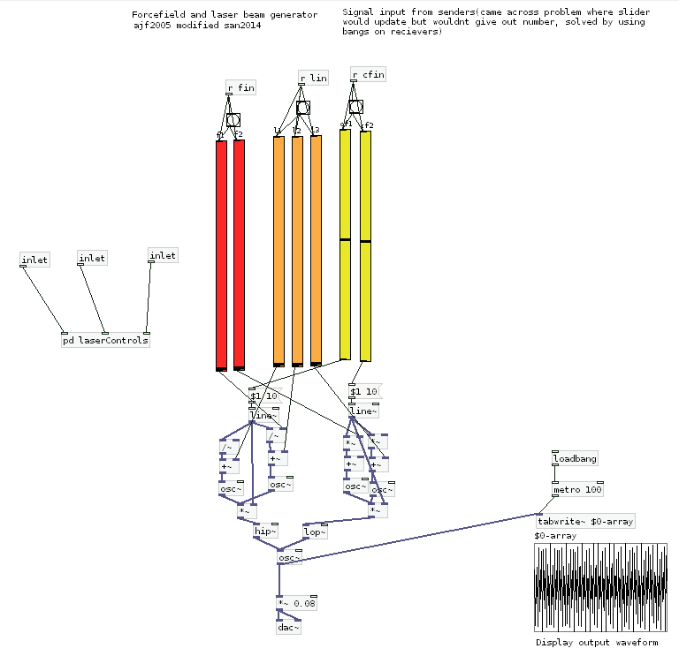

**References/ Accolades**

Original concept for laser beam sound;

<http://obiwannabe.co.uk/tutorials/html/tutorial_laserbeam.html>